CS 255 System Design Document

This template lays out all the different sections that you need to complete for Project Two. Each section has guidance to prompt your thinking. You will need to continually reference the interview transcript as you work to make sure that you are addressing your client’s needs. There is no required length for the final document. Instead the goal is to complete each section based on what your client’s needs are. Remove this note when you are finished, and replace all bracketed text with the relevant information.

UML Diagrams

UML Use Case Diagram
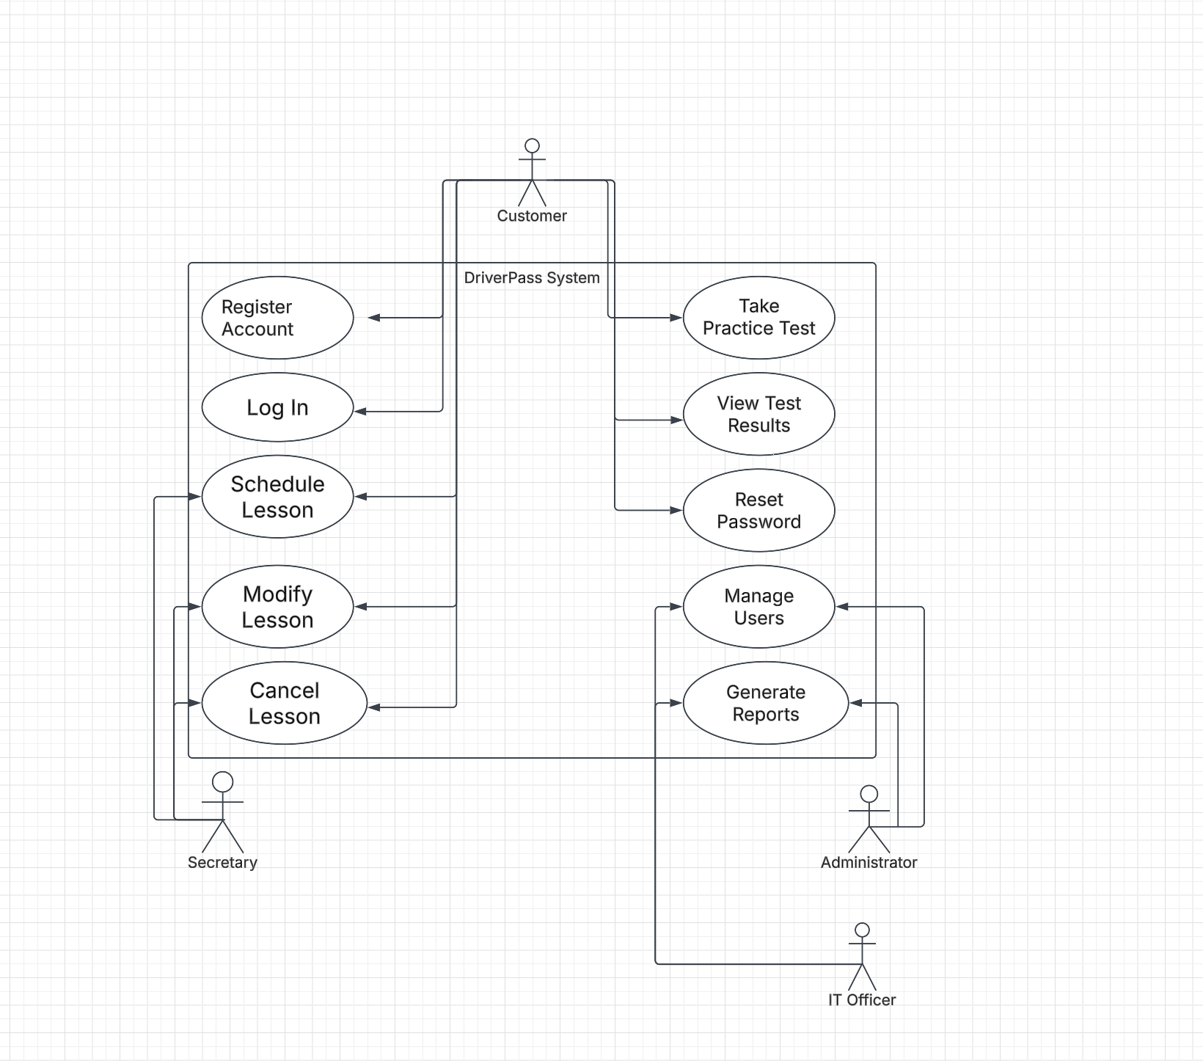

UML Activity Diagrams
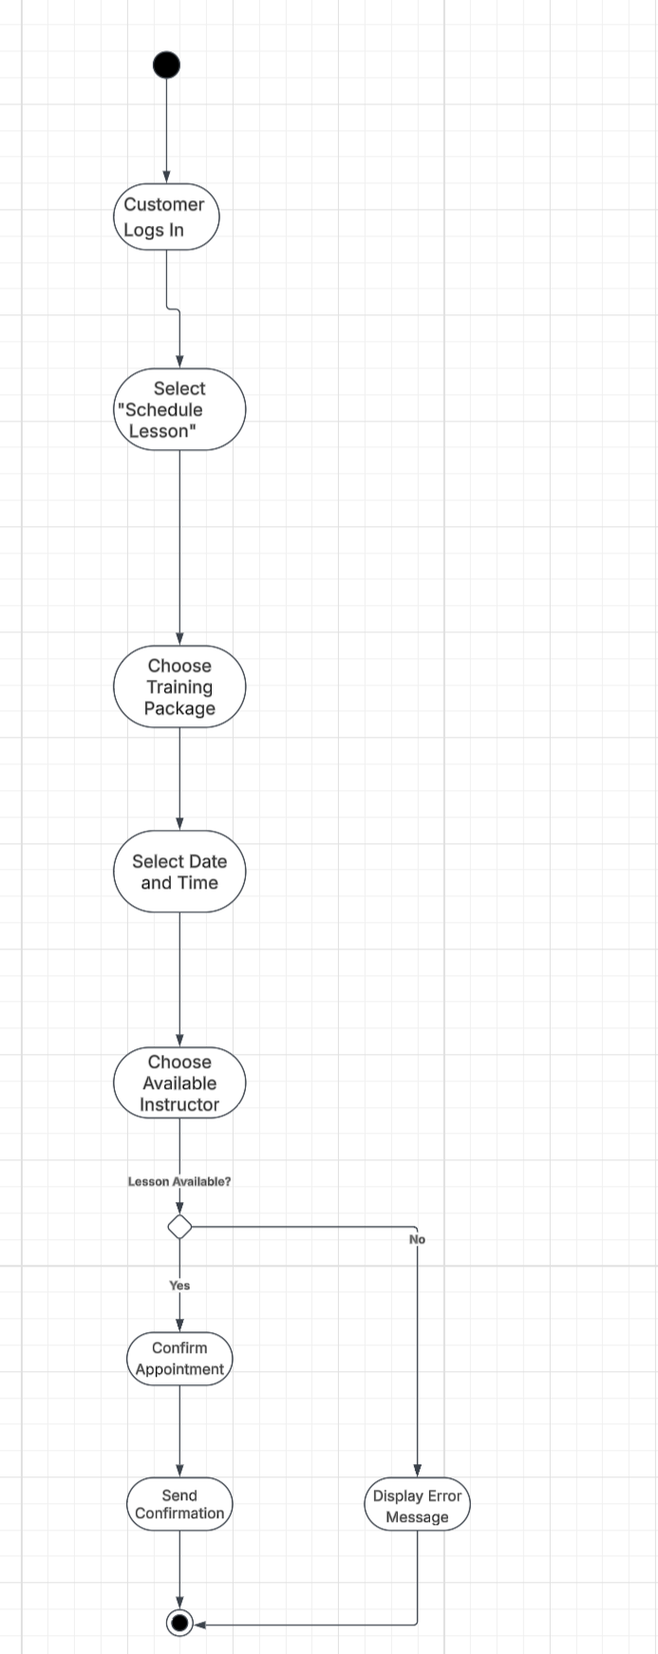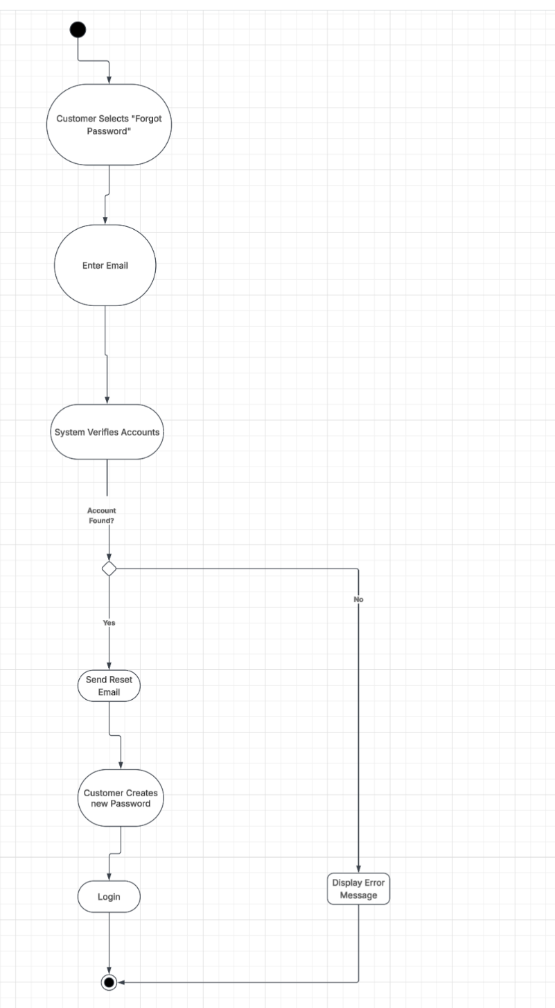

UML Sequence Diagram
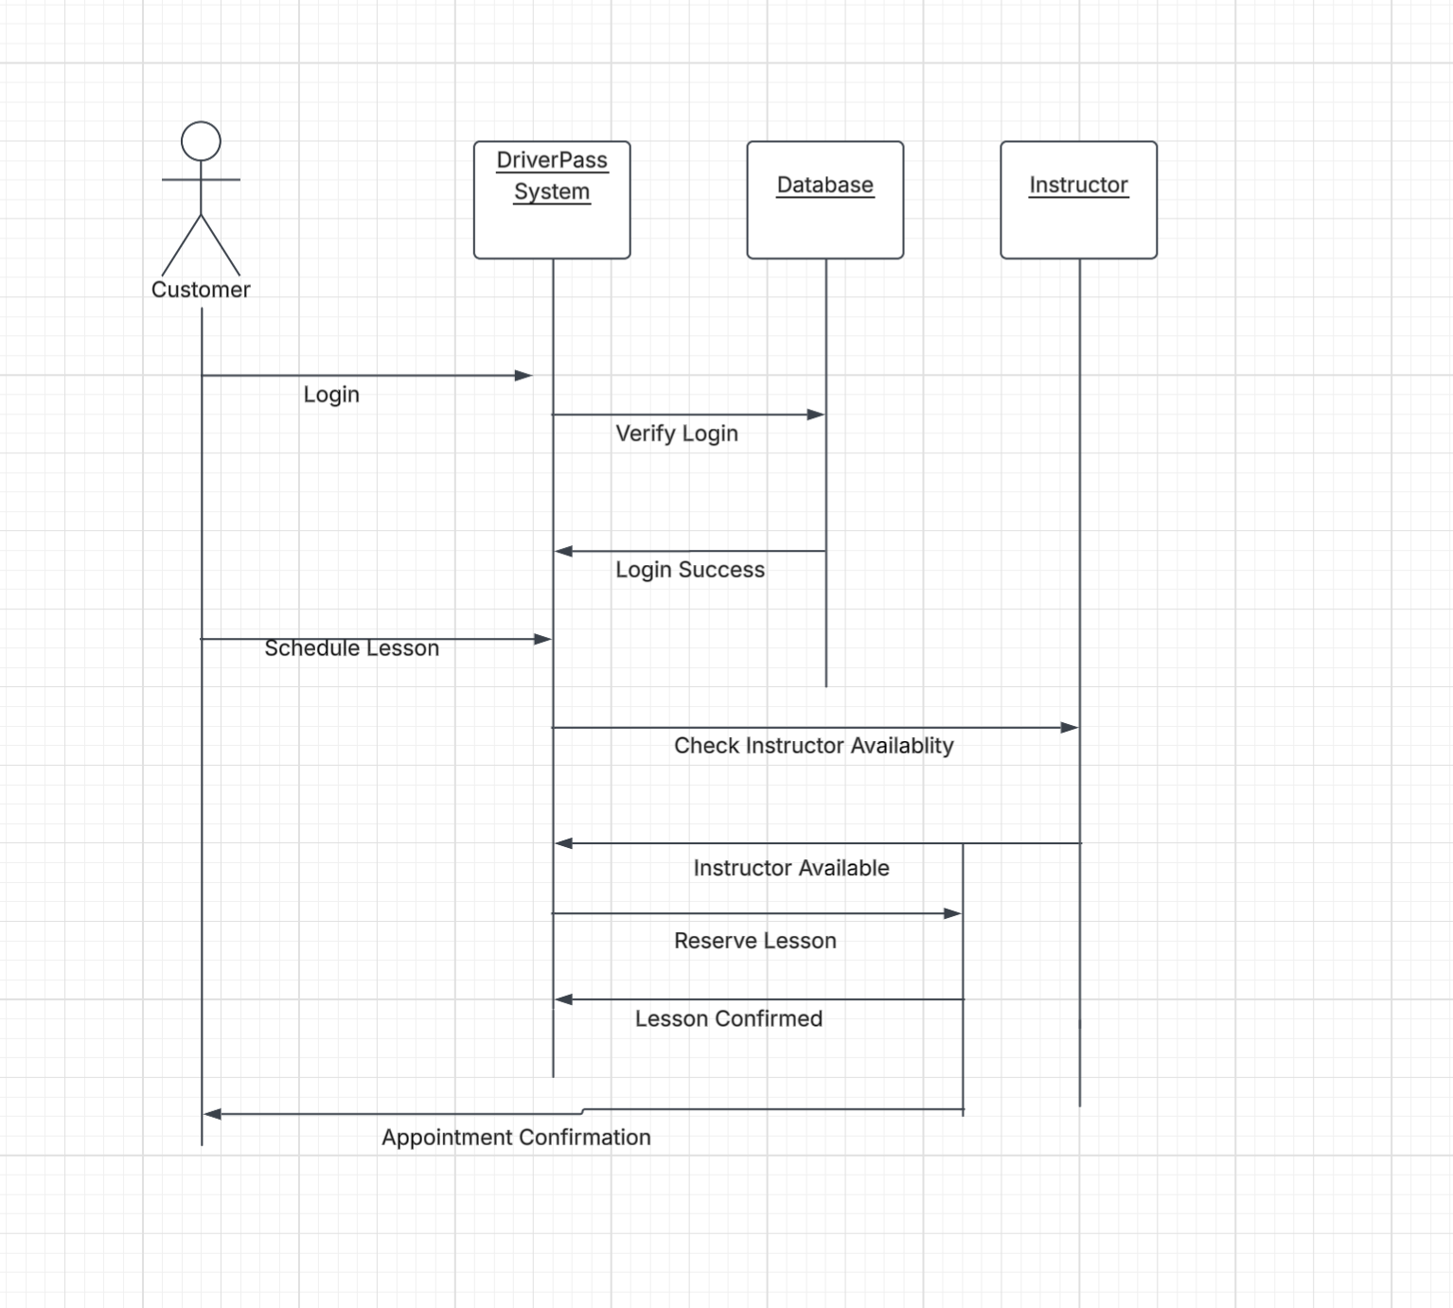

UML Class Diagram
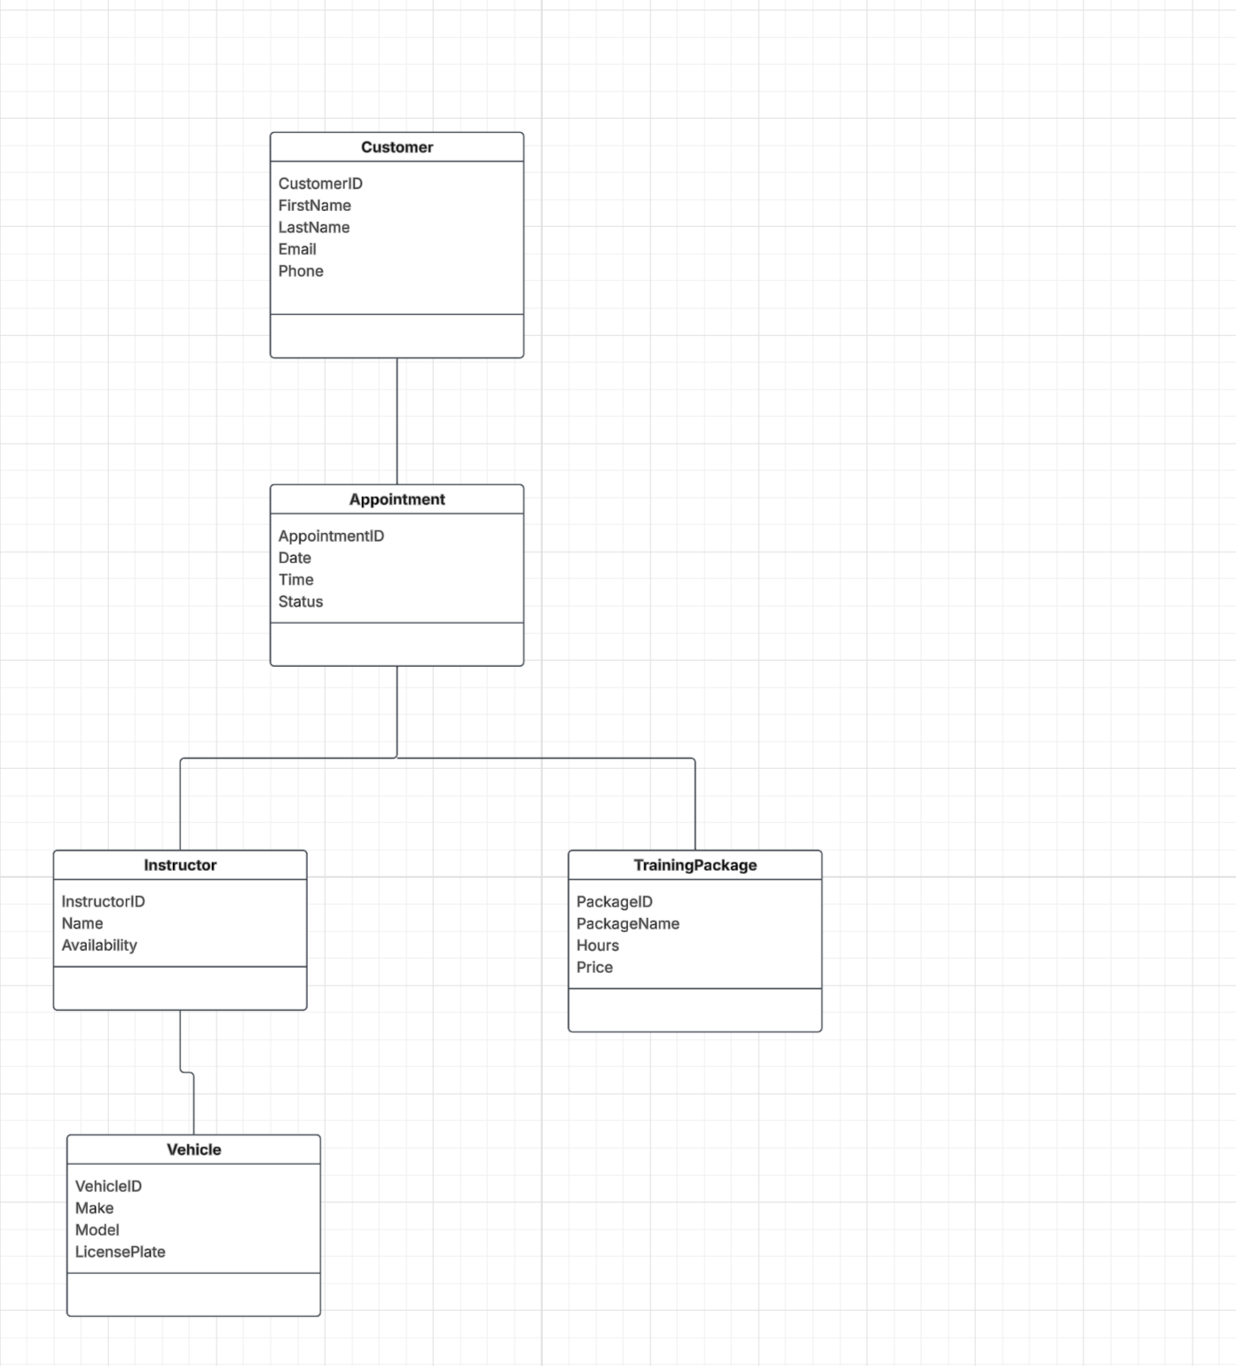

Technical Requirements
The DriverPass system will be a web-based application that can be accessed from computers, tablets, and smartphones with an internet connection. The system should be hosted on a secure cloud server so customers and employees can use it from different locations. A MySQL database will be used to store customer accounts, appointments, instructor schedules, training packages, and practice test results. The development team can use Lucidchart to create UML diagrams and an IDE such as Eclipse or Visual Studio Code to build and maintain the system. The application should also include secure user login, encrypted passwords, automatic backups, and role-based access to help protect customer information and keep the system running reliably.

